[Sales Mix Extraction Tool](https://employees.washucarwash.com/salesmix)

Version 4.1

09/18/2023

**Description**:

The Sales Mix Extraction Tool is designed to extract sales data from a General Sales Report (GSR), transform the CSV data into useful statistics, graphs, charts and load it all into an excel sheet. Data includes: sales mix, discounts mix, member analysis, and revenue analysis.

**Dependencies**:

* Access to SiteWatch Web (Version 27+) and the ability to run/export GSRs for all locations.

**Instructions**:

1. Visit [SiteWatch Web](https://www.sitewatch.cloud/) and login with your user ID, Password and Location Code (WSHUIL-001).

1. Go to **Financial Reports** on the left hand side, and then click **General Sales**

1. In the top right, click **wash*u – Plainfield** and select **All Sites.** Click apply to save the site selection.

1. Click **Options** (if it did not open automatically) to make this format pane available.

1. Select the date range you would like to run the report for. **It is suggested that the date range be “whole months”. I.e.: July 15th to September 15th or September 1st, 2022, to August 31st, 2023. Date ranges that are less than a month or contain partial months could produce inaccurate or misleading data. Ideally the report is run for a single month period however it can adapt to longer periods.**
2. Toggle OFF Video Queue 3 from the **Terminals** list.

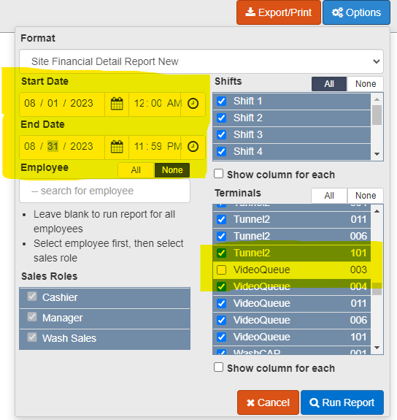

1. Click **Run Report** and allow the server a few moments to generate the GSR.
2. Once generated, click export, and use the following settings:

1. Now, with your new CSV file, head on over to the [Sales Mix Extraction Tool](https://employees.washucarwash.com/salesmix), upload the CSV you just downloaded and then click “Generate Report”.